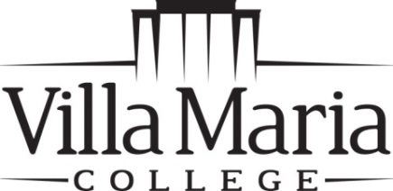

Office of the Registrar
240 Pine Ridge Road • Buffalo, NY 14225
(716) 896-0700 • FAX (716) 896-0705

NON-CREDIT / AUDIT TO CREDIT REQUEST

Student Name _________________________________________________________

Student ID# _____________________________________ Semester ____________

I am currently registered as:

______ Non-Credit Student

______ Audit Student

______________________ ___________________________________________
Course Number & Section Course Title

I request that my registration be changed to Non-Matriculated in order to earn college credit for this course. I understand that I must meet all course requirements and that I must pay all required fees and tuition that apply for courses with credit.

__________________________________________________ ________________
Student Signature Date

__________________________________________________ ________________
Instructor’s Signature Date

__________________________________________________ ________________
Vice President of Business Affairs Signature Date

7-29-13 dar

