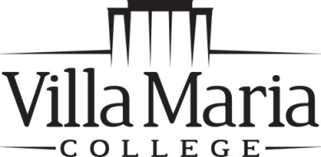
Registrar’s Office
240 Pine Ridge Road • Buffalo, NY 14225
(716) 896-0700 • FAX (716) 896-0705

ENROLLMENT VERIFICATION REQUEST

Name _____________________________________________ Student ID # ________________________

Semester and Year Verification Requested for:

Fall Spring Summer Year(s)_____________________________
(Circle all that Apply)

Information Requested for Verification:

______ Registration Status

______ Expected Graduation Date

______ Degree Completion Date

Verification Information: Pick-Up Mailed Faxed
(Circle all that Apply)

Mailing Address

Name ____________________________________________________________________________

Address __________________________________________________________________________

City _______________________________ State ______________ ZIP Code _____________

Fax to:

Company Name ______________________________________ Fax Number _______________________

Attention: ______________________________________________________________________________

Student Signature __________________________________________ Date _______________________

8-12-13 dar

