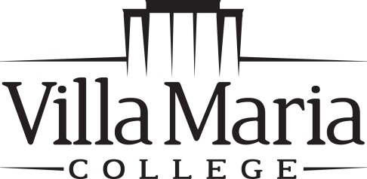

Office of the Registrar
240 Pine Ridge Road • Buffalo, NY 14225
(716) 896-0700 • FAX (716) 896-0705

NAME / ADDRESS CHANGE

Name Change

Legal proof of name change (social security card) must be provided with request.

Name ________________________________________________________________________

Name Change ________________________________________________________________________

Signature ____________________________________________ Date _____________________

___________________________________________________________________

Address Change

Name ________________________________________________________________________

Name ________________________________________________________________________
(While Attending)

New Address ________________________________________________________________________
Street

___________________________________ ______________ _____________
City State Zip Code

Phone # ________________________________ Cell Phone # ________________________________

Signature ____________________________________________ Date _____________________

dar 7-8-13

